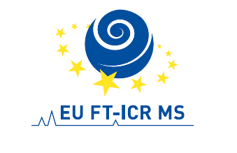

EU FT-ICR MS, 9th SHORT COURSE
University of Eastern Finland (UEF), Department of Chemistry,
Joensuu, Finland, April 19–22, 2022

Application Form

First name:
Last name:
Male Female
Institution:
Address:
City:
Country:
Email:
Position (at your institution):
Degree : BSc MSc PhD Other
Specialization area in chemistry:
Organic Inorganic Bioinorganic Biological
Physical Other (please, specify):

Experience in mass spectrometry (in years):
Do you want to have a short talk (5-10 min) in the school? Yes No
If yes, please give a short title or subject:

Please, include with your application 1) short CV and 2) motivation letter (max. 1 page) where you describe why this school would be important to you!

Date Signature: ___________________

Please, fill in, print and sign the document (by hand or electronically) and send PDF copy (preferably including attachments) to janne.janis@uef.fi

THE DEADLINE FOR APPLICATIONS IS APRIL 5, 2022!

